# Working with Forms - Lab

## Topics Covered

* Web forms are a very powerful tool for interacting with users — most commonly they are used for collecting data from users or allowing them to control a user interface.

## Resources

* **Web form building blocks**
  + https://developer.mozilla.org/en-US/docs/Learn/Forms

## Tasks

### Form Element

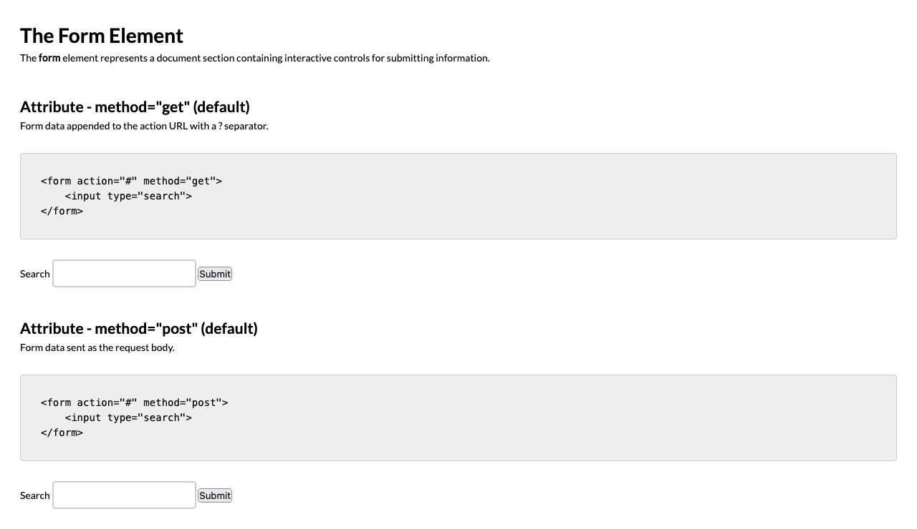

*For full screenshot check the screenshot.png file in the folder for the task*

#### Objective:

Create a webpage that looks like the screenshot above.

#### Requirements:

1. **File Setup**:
   * Create an **HTML** document named **form-element.html**
   * Create a **CSS** file named **form-element.css**
2. **Element creation**
   * Add title of the page in an **<h1>** element
   * Add **<h2>** elements and **p** elements for each **<h2>** as shown on the screenshot
3. **Styling**
   * Add the standard reset styling – padding, margin, box-sizing
   * Add the following styles to the HTML element
     1. Font – 14px/1.5 Lato, sans-serif
   * Inherit the font styling on these elements – body, input, textarea, select, option
   * Add padding of 2 em to the body element
   * Add margin-top of 2em to all h2 elements
   * Add the following styles to the code elements:
     1. Display – block
     2. Padding – 2em 2em 0.5em 2em
     3. Border-radius – 0.3em
     4. Margin – 2em 0
     5. Border – 1px solid #ccc
     6. Overlow – auto
   * Add the following styles to the input elements:
     1. Display – inline-block
     2. Padding – 0.5em 0.8em
     3. Border – 2px solid #ccc
     4. Outline – none
   * Add the following styles to the input when focused:
     1. Border-color – #090

### Text input

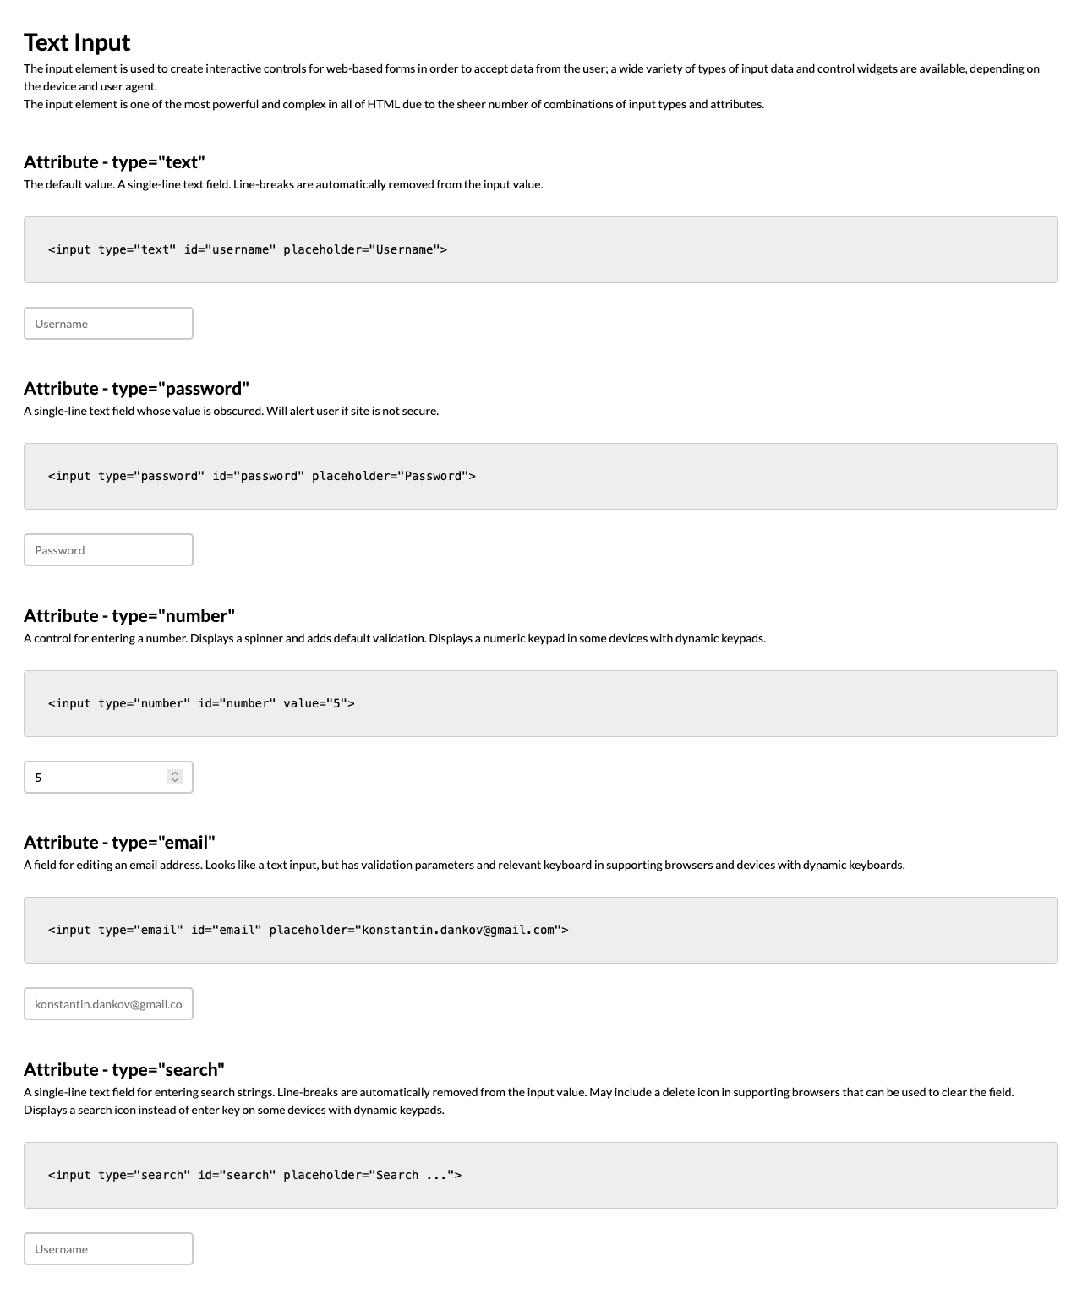

*For full screenshot check the screenshot.png file in the folder for the task*

#### Objective:

Create a webpage that looks like the screenshot above.

#### Requirements:

1. **File Setup**:
   * Create an **HTML** document named **text-input.html**
   * Create a **CSS** file named **text-input.css**
2. **Element creation**
   * Add title of the page in an **<h1>** element
   * Add **<h2>** elements and **p** elements for each **<h2>** as shown on the screenshot
3. **Styling**
   * Copy the styling from Task 1

### Textarea

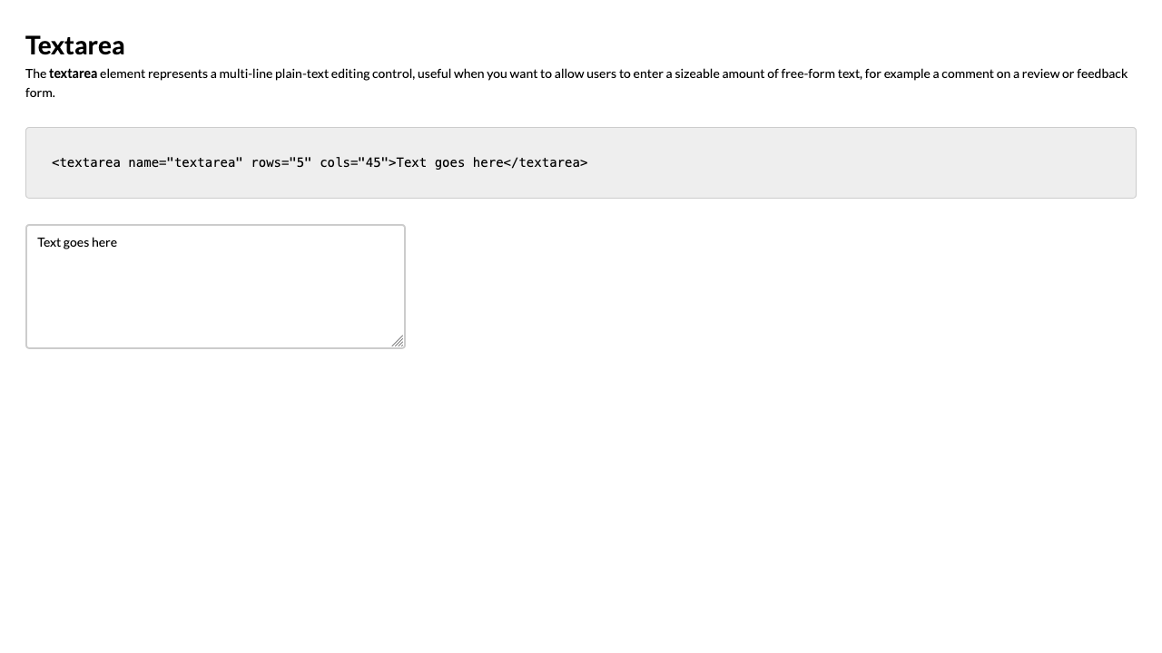

*For full screenshot check the screenshot.png file in the folder for the task*

#### Objective:

Create a webpage that looks like the screenshot above.

#### Requirements:

1. **File Setup**:
   * Create an **HTML** document named **media-types.html**
   * Create a **CSS** file named **media-types.css**
2. **Element creation**
   * Add title of the page in an **<h1>** element
   * Add **<h2>** elements and **p** elements for each **<h2>** as shown on the screenshot
3. **Styling**
   * Copy the styling from Task 1
   * Make sure the textarea has the same styling as the input elements

### Radio

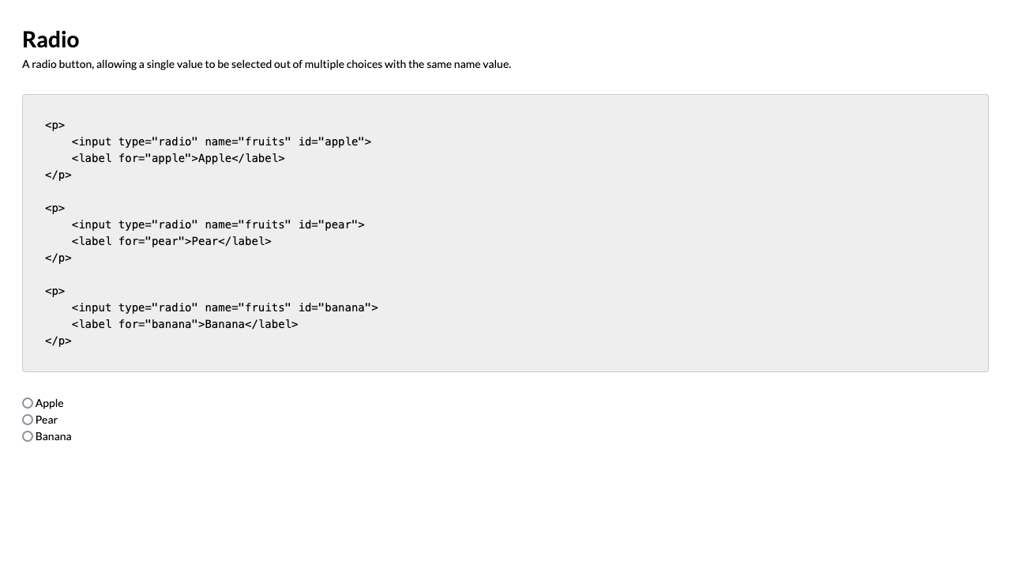

*For full screenshot check the screenshot.png file in the folder for the task*

#### Objective:

Create a webpage that looks like the screenshot above.

#### Requirements:

1. **File Setup**:
   * Create an **HTML** document named **radio.html**
   * Create a **CSS** file named **radio.css**
2. **Element creation**
   * Add title of the page in an **<h1>** element
   * Add **<h2>** elements and **p** elements for each **<h2>** as shown on the screenshot
3. **Styling**
   * Copy the styling from Task 1

### Checkbox

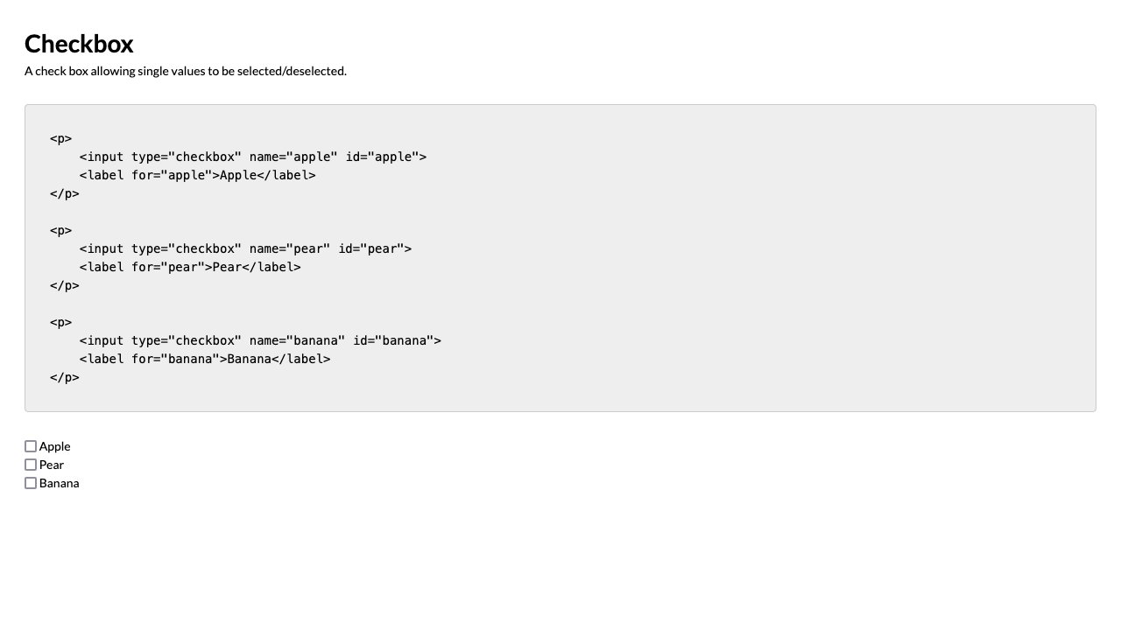

*For full screenshot check the screenshot.png file in the folder for the task*

#### Objective:

Create a webpage that looks like the screenshot above.

#### Requirements:

1. **File Setup**:
   * Create an **HTML** document named **media-types.html**
   * Create a **CSS** file named **media-types.css**
2. **Element creation**
   * Add title of the page in an **<h1>** element
   * Add **<h2>** elements and **p** elements for each **<h2>** as shown on the screenshot
3. **Styling**
   * Copy the styling from Task 1

### Select

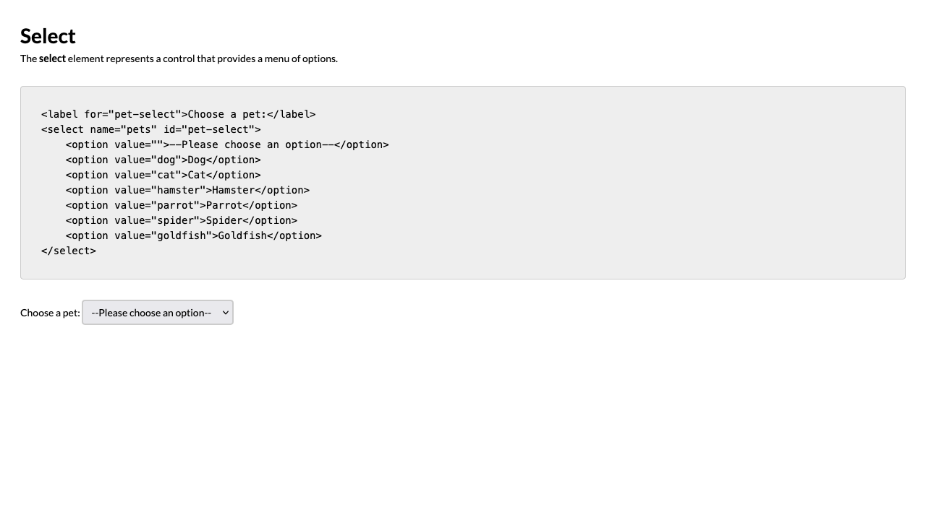

*For full screenshot check the screenshot.png file in the folder for the task*

#### Objective:

Create a webpage that looks like the screenshot above.

#### Requirements:

1. **File Setup**:
   * Create an **HTML** document named **select.html**
   * Create a **CSS** file named **select.css**
2. **Element creation**
   * Add title of the page in an **<h1>** element
   * Add **<h2>** elements and **p** elements for each **<h2>** as shown on the screenshot
3. **Styling**
   * Copy the styling from Task 1
   * Add the following styles to the select elements:
     1. Display – inline-block
     2. Padding – 0.5em 0.8em
     3. Border – 2px solid #ccc
     4. Border-radius – 0.3em

### Multiselect

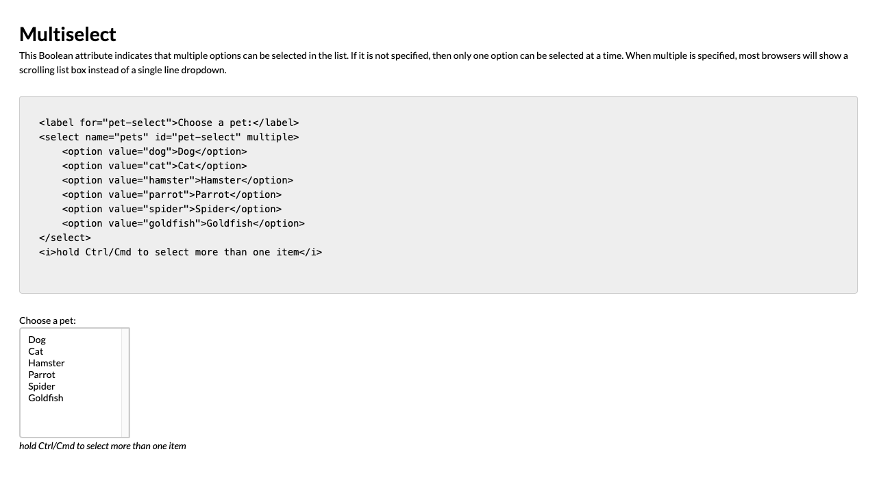

*For full screenshot check the screenshot.png file in the folder for the task*

#### Objective:

Create a webpage that looks like the screenshot above.

#### Requirements:

1. **File Setup**:
   * Create an **HTML** document named **media-types.html**
   * Create a **CSS** file named **media-types.css**
2. **Element creation**
   * Add title of the page in an **<h1>** element
   * Add **<h2>** elements and **p** elements for each **<h2>** as shown on the screenshot
3. **Styling**
   * Copy the styling from Task 6
   * Add the following styles to the select elements who have the multiple attribute:
     1. Display – block
     2. Min-width – 20ch
     3. Min-height – 20ch

### Fieldset

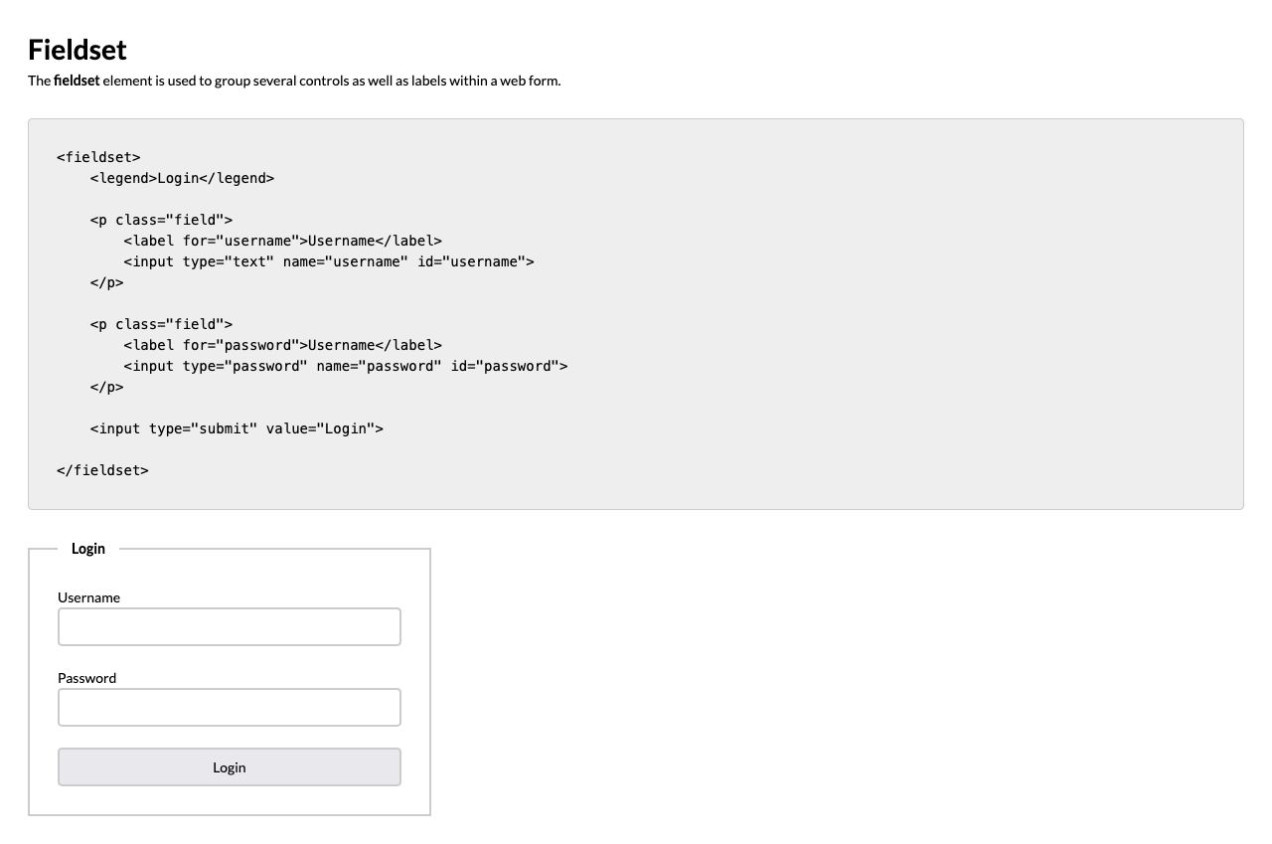

*For full screenshot check the screenshot.png file in the folder for the task*

#### Objective:

Create a webpage that looks like the screenshot above.

#### Requirements:

1. **File Setup**:
   * Create an **HTML** document named **media-types.html**
   * Create a **CSS** file named **media-types.css**
2. **Element creation**
   * Add title of the page in an **<h1>** element
   * Add **<h2>** elements and **p** elements for each **<h2>** as shown on the screenshot
   * Add a **fieldset** element with a legend element as shown in the screenshot
   * Add **label** elements and **input** elements and surround each pair with a **paragraph** with a class of "field"
3. **Styling**
   * Copy the styling from Task 1
   * Add the following styles to the fieldset elements:
     1. Padding – 2em
     2. Border – 2px solid #ccc
     3. Max-width – 50ch
   * Add the following styles to the legend elements that are inside of a fieldset:
     1. Padding – 0 1em
     2. Font-weight – bold
   * Add font-weight – bold to all labels inside of the fieldset
   * Add the following styles to all input elements inside of the fieldset:
     1. Display – block
     2. Width – 100%
   * Add padding-bottom of 1.5em to all elements with a class of field